# ECE 162 Week 9 – Pulse Generator

Name: Brian Loughran (btl217@lehigh.edu)

## Purpose

In this lab we will be building a pulse generator.

## Theory

In this lab we are building a pulse generator using a 555 timer to control the pulses. A figure of the system is shown below in Figure 1:

Figure 1

Where in this figure RA = 1 kΩ, RB = 10 kΩ, and capacitance C = 4.7 μF.

When looking at the voltage vs. time plots of this circuit diagram, one can observe that the plot is a square waveform. The magnitude of the waveform starts at zero, and reaches near the input voltage. Considering an input voltage of 9V, we could expect the output voltage when the waveform is in the “high” state to be slightly less than 9, maybe around 8V. The ratio of the time when a square wave is in its “high” state to the time a square wave is in its “low” state is known as the mark to space ratio. This ratio is effected by the values for resistance and capacitance used in the circuit. Starting with the time that the square wave is in the “high” state, the equation for this time is given by equation 1 below:

$$t_{1}=0.69 C \left(R_{A}+ R_{B}\right) (eq.1)$$

Conversely, the equation for the time that the waveform is in the “low” state is given by a different equation, and that equation is shown below (equation 2):

$$t_{2}=0.69 C R_{B} (eq.2)$$

As mentioned earlier, the mark to space ratio is the ratio of these two times. For clarification, this equation is shown below in equation 3:

$$Mark to Space= \frac{t_{1}}{t_{2}} (eq.3)$$

One final equation which can be useful in analyzing this circuit is the relationship between frequency and the period. This was covered in other labs, but since we are using this equation in this lab as well, it is included as equation 4 below:

$$t=\frac{1}{f} (eq.4)$$

## Experimental Method

* Build the circuit from Figure 1
* Record the generated waveform
* Measure the mark to space ratio by comparing the time on “high” and the time on “low” and computing the ratio of the two
* Calculate period and frequency

## Diagram

Shown below is a figure describing our LabView block diagram. This is very similar to the LabView VI which we used in the previous week, as in this lab we are again plotting two waveforms on the same plot. This requires two inputs for the sampling rate. The block diagram is included below in Figure 2:

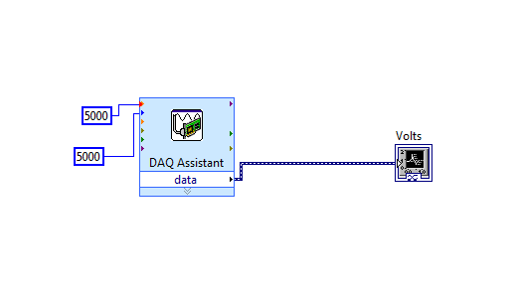

Figure 2

## Results

A first plot was taken to check the shape of the waveform that we were generating and to get a general idea of what to expect in terms of frequency, magnitude and mark to space ratio. This plot is shown below, and gives a good idea of what is going on in the system. This plot is Figure 3:

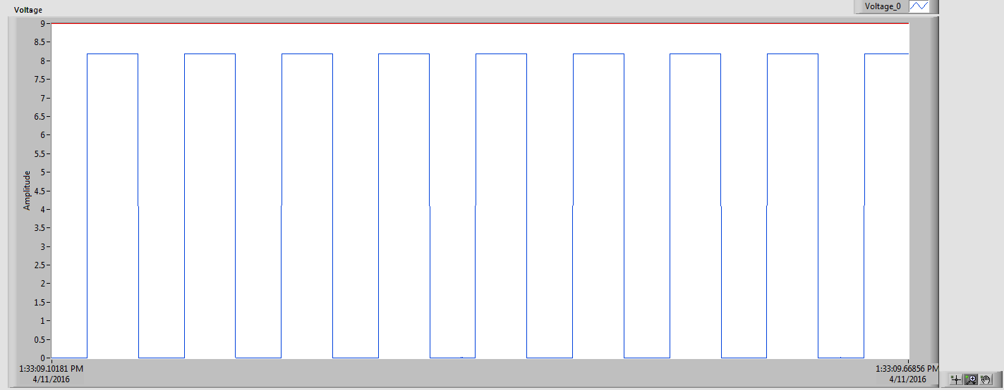

Figure 3

As you can see, the waveform generated is exactly what was expected. The horizontal line around 9V at the top of the plot is the input voltage. Below you can see the generated waveform. As discussed in the theory section, the maximum voltage of the generated waveform is near, but not equal to the magnitude of the input voltage. The shape is very good, as the time it takes to move from the “low” state and “high” state is effectively 0.

Below is a table analyzing the mark to space ratio. We zoomed in on the graph to the point where we could only see the “high” state, and analyzed the time stamps to find the time that the waveform spent on the “high state. Next we did the same thing for the “low” state. Table 1 below shows the results of this:

|  |  |  |
| --- | --- | --- |
| t1 “high” (s) | t2 “low” (s) | Mark to space ratio |
| .0338 | .0306 | 1.104 |

Table 1

Combining equations 1-3 give a relationship for the mark to space ratio which is a function of only the resistance and capacitance used for the circuit. For the values given, we was that there was a mark to space ratio (calculated) of 1.102. This is very close to the value which was found experimentally, which validates the experiment.

Next we can experimentally determine the period and frequency of the square waveform which we generated. This was done by first zooming in on exactly 5 periods in LabView. Then we checked the time stamps and divided the difference by 5 to find the period of a single period. The result of this was that the period was measured to be .0649s. This 5 cycle plot is shown below in Figure 4 below:

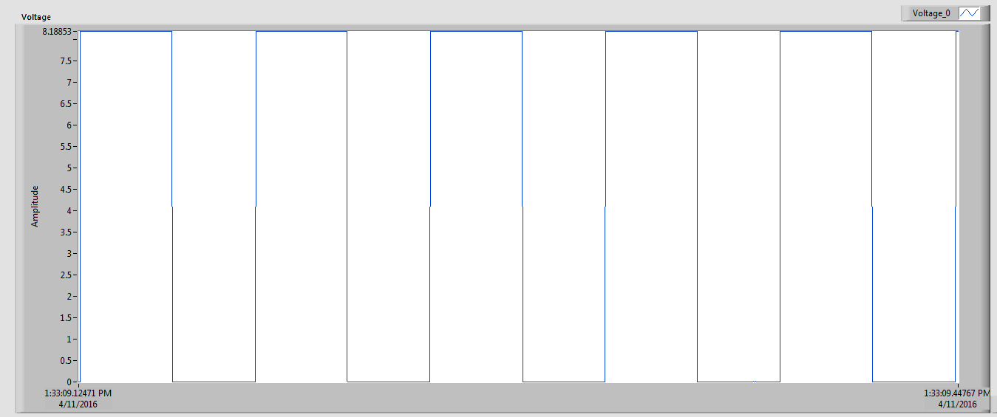

Figure 4

Another way to do this is to simply add the time the waveform spent in the “high” state to the time the waveform spent in the “low” state. The result of this is a period of .06442 s, which is very close to the other measured value for period. This again further validates the experimental system.

To find the frequency of the waveform, we can simply inverse the period (eq. 3). The result of this is a frequency of 15.48 Hz (1/s).

## Discussion

The results from the previous section were compiled into a table in order to more easily compare the values to each other, and to take a look at percent error throughout the lab. This table (Table 2) is shown below:

|  |  |  |
| --- | --- | --- |
| Mark to space experimental | Mark to space calculated | % error |
| 1.104 | 1.102 | .18% |

Table 2

As you can see there was minimal error in calculating the mark to space ratio for the waveform which we created with the 555 timer. This means that the equipment which we are using to create and measure this waveform is highly accurate. This speaks to the accuracy of the data acquisition unit which we use in this class (which effortlessly measures voltages at 5000 data points per second). This also speaks to the integrity of the 555 timer, as it appears to be very accurate. All in all, this lab went very well, and the results were spot on.

## Conclusion

The purpose of this lab was to create a square waveform using the 555 timer and given resistor and capacitor values. Using different values for resistors and capacitors can give different values for the mark to space ratio with values either greater than or less than one, depending on the values selected. This makes the 555 timer not only a good device to measure time, but also a good device to create square waveforms.